The OGF Enterprise Function:
In the spirit of carrying-out the OGF mission, the OGF Enterprise function focuses on building an international community to accelerate the adoption of Grid specifically within the enterprise. In this context, the term “enterprise” more specifically refers to types of individuals rather than a particular type of organization, since for instance, there is overlap between academic institutions as enterprises and what we traditional think of as businesses as being enterprises.
The Enterprise function is roughly divided into two interconnected hemispheres:

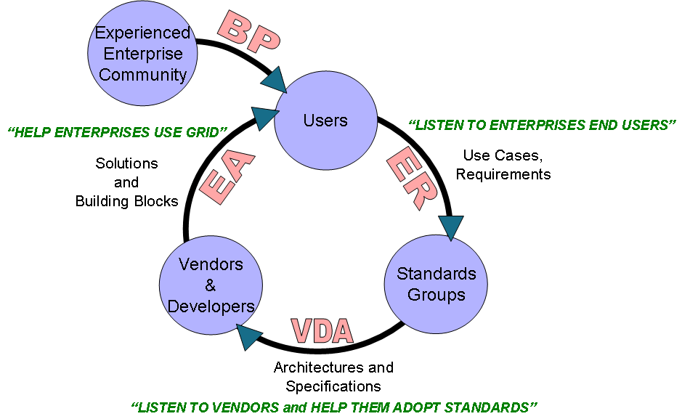 | - The first hemisphere of the Enterprise function focuses on the use of Grid technology in the “here and now” to help enterprise IT & line of business end users achieve business value by applying Grid technology that is already available today. This activity is the responsibility of two specific focus areas: 1) the Enterprise Adoption focus area, and 2) the Best Practices focus area.  - The second hemisphere of the Enterprise function focuses on the longer-term effort of developing open standards ensuring that these standards comprehend the requirements of the enterprise community. Once the standards exist, the Enterprise function works with vendors and developers to implement the standards into new Grid solutions and building blocks. This set of activities is the responsibility of two specific focus areas: 1) the Enterprise Requirements focus area, and 2) the Vendor & Developer Adoption focus area. Ultimately, this activity feeds into the first hemisphere of the Enterprise function described above once specifications based on new Grid solutions and building blocks are produced that are based on the standards that comprehend enterprise requirements.
Enterprise Requirements
The Enterprise Requirements focus area addresses the longer-term standards development effort to ensure that OGF standards represent the needs of the Enterprise and eScience end-user communities. The Enterprise Requirements focus area reaches-out to the broader Grid community who may not be involved in the OGF standards development process; however, are representative of the decision makers and implementers of the technology thus being the end-user targets of the standards.
Enterprise Adoption
The Enterprise Adoption focus area has more of an outreach role to help enterprise IT & line of business end users achieve business value by applying currently available Grid technology; as well as help enterprises understand the potential business benefit of Grid technology so that they can more appropriately plan for changes to their business process, line of business applications as well as changes to IT.
Vendor and Developer Adoption
The Vendor & Developer Adoption focus area works with the vendors & developers to comprehend the economic and practical factors that will make OGF standards cost effective for vendors & developer to adopt.
Best Practices
The Best Practices focus area directly supports the Enterprise Adoption focus area by capturing existing best practices that address the use and application of currently available Grid technology. Best Practices may originate from actual end users who have applied grid technology to solve a business problem, or they may originate from vendors & developers who have produced solutions and building blocks that are intended to solve a particular end user business problem

